!. we have created the file as dockerfile.txt

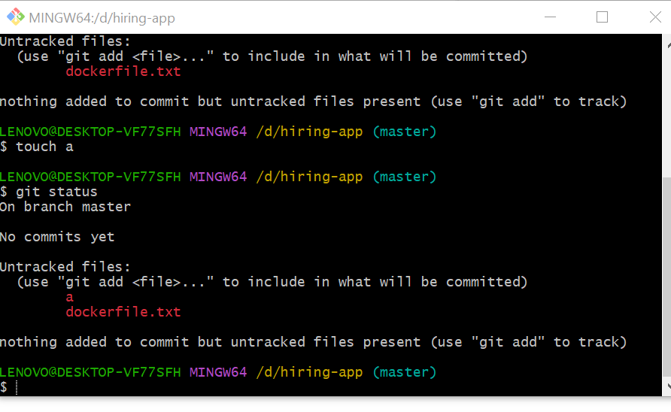

1. Here we have configure the user name and email

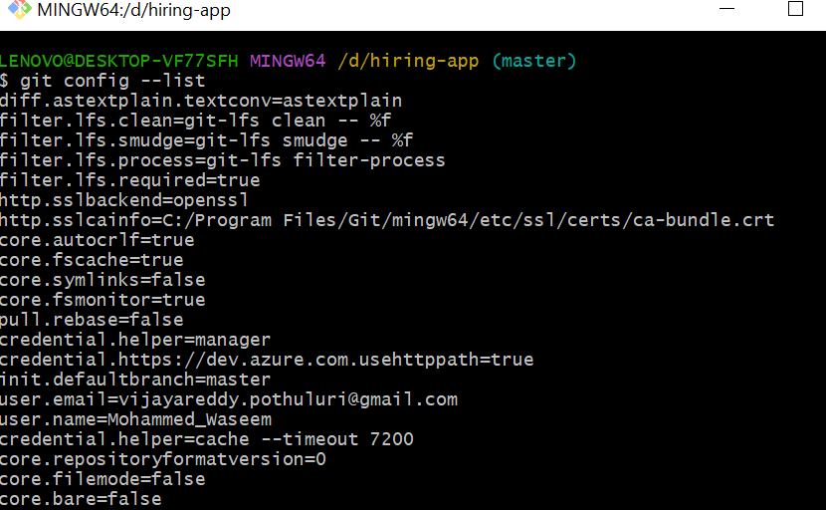

1. Here we have tracked the files

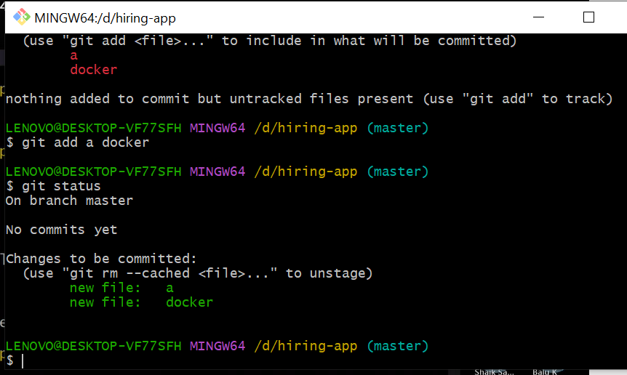

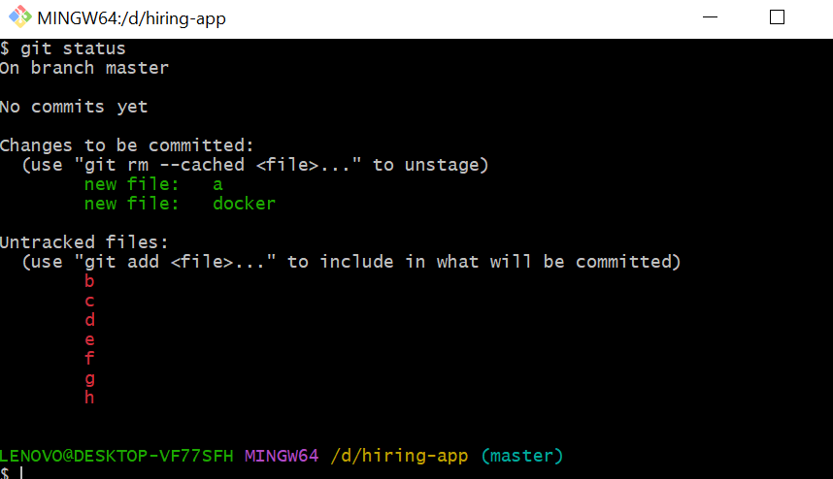

1. Here its shows the untracked files are now tracked with command git add . to add the files in tracking area

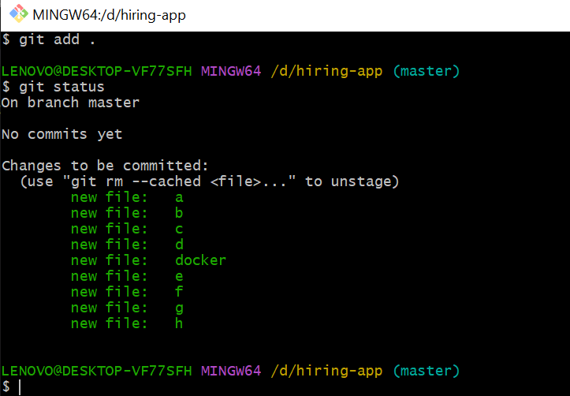

5. Here we have use the command git commit -m “added coupe of file” and it will get added in the files as total 9 and its on branch master and there is no new files in tracking and untracking area

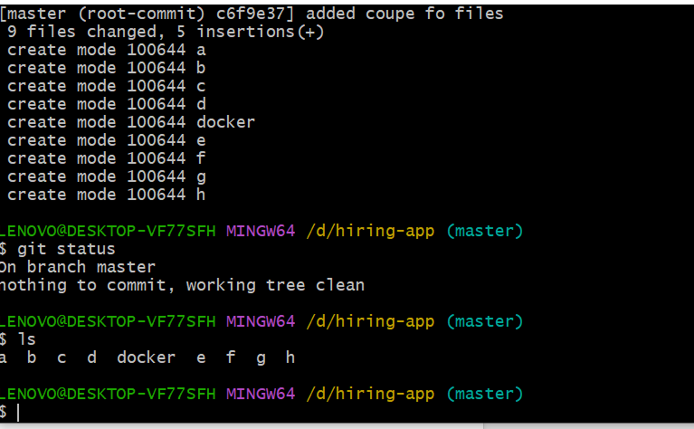

6. With command git log we can check the commit ID and check all the changes

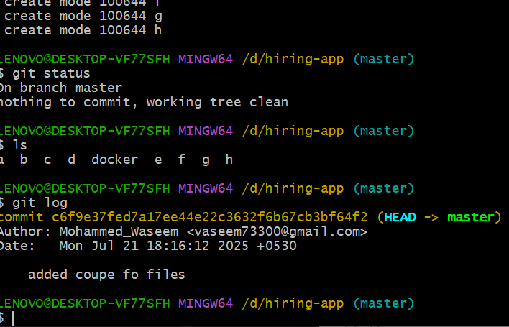

1. Here we have add SSH mail from the github

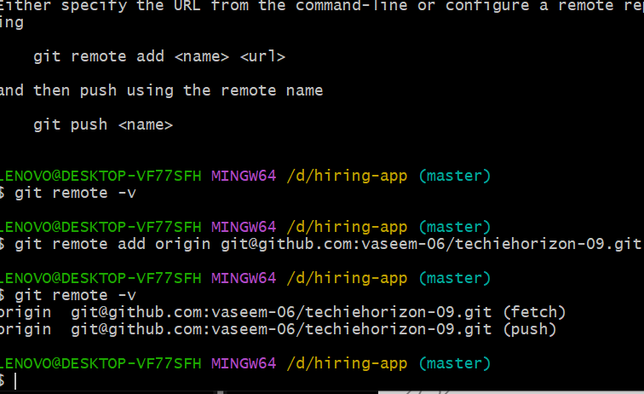

1. Here we have generated the SSH key using the command ssh-keygen

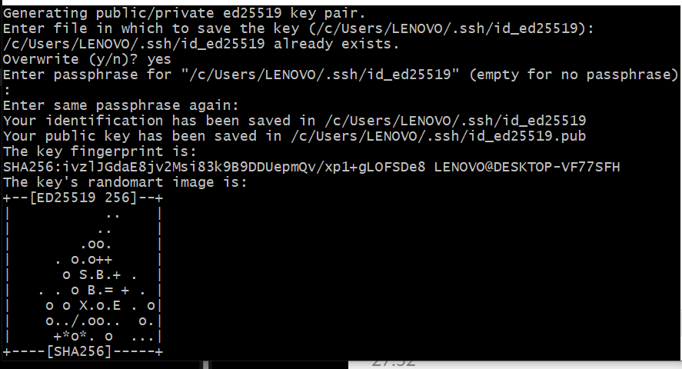

1. After created the keygen we have used the command git push -u origin master and it shows all the details of files and added in the techiehorizon-09 and shows that from local to repository we did

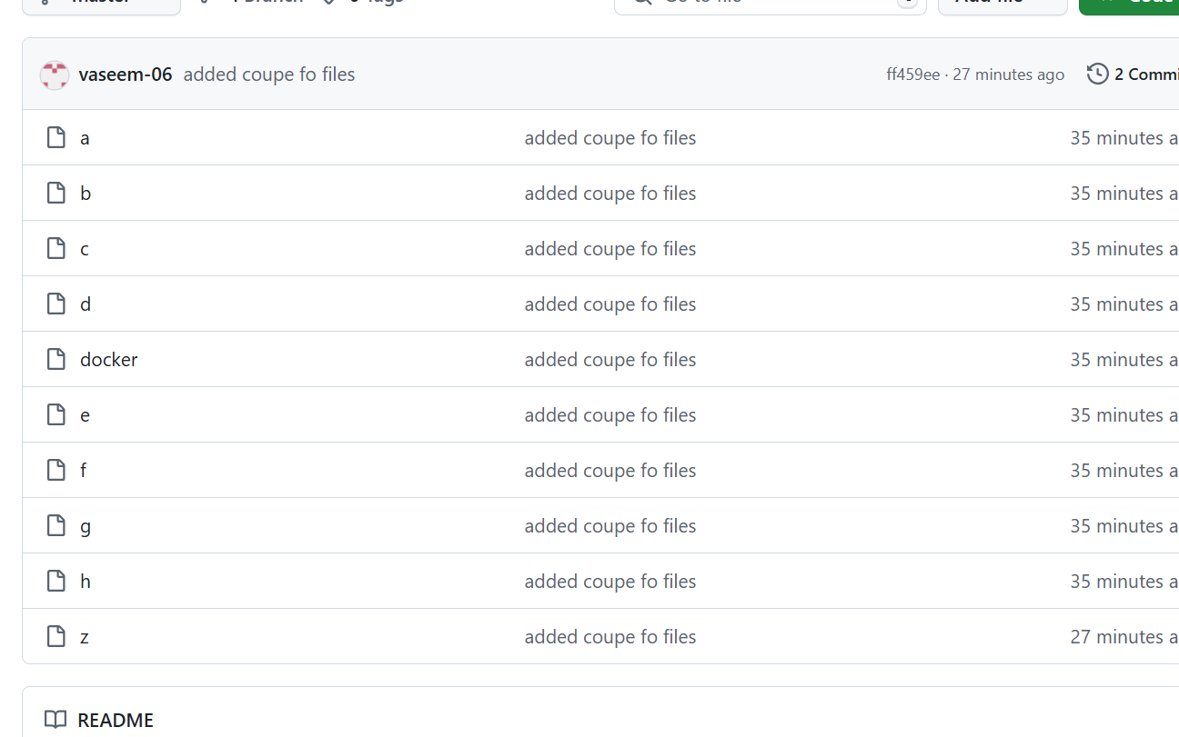

1. Here we have deleted he in local but it will not deleted from repository

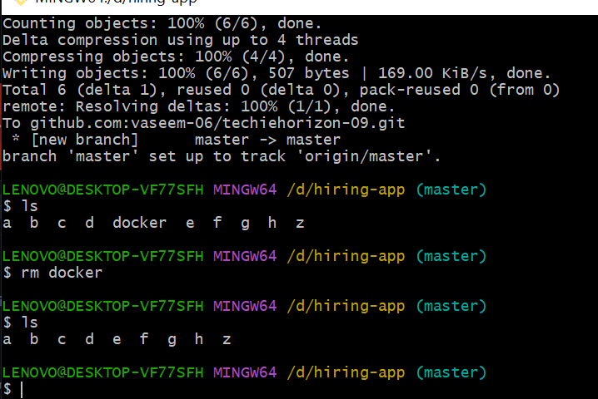

1. And shows the git status it deleted

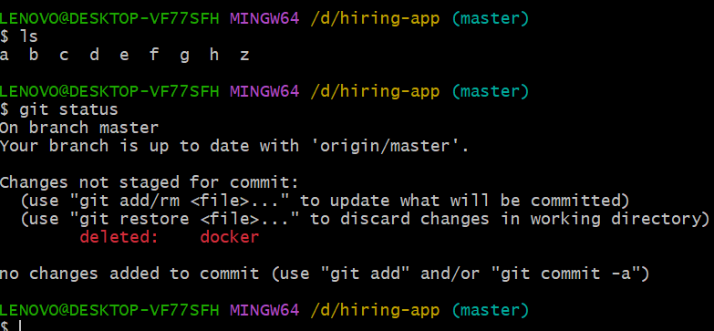

1. Here we have use the command git push origin master and it got deleted from repository

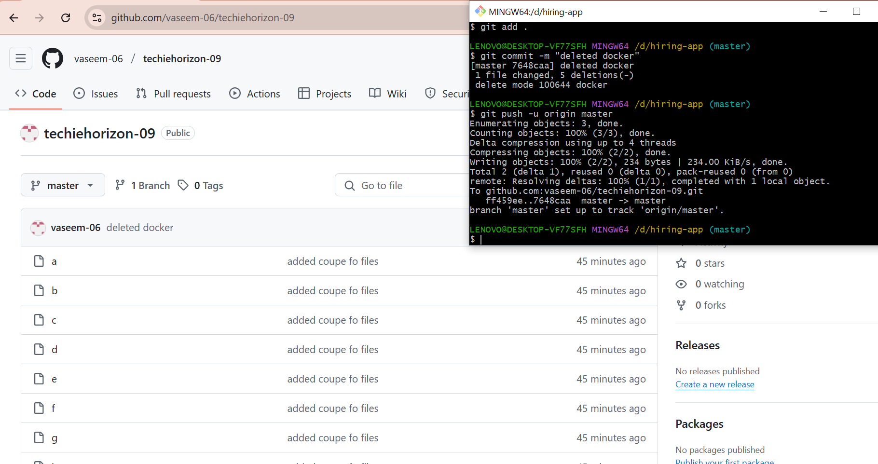

1. It shows the git push command got rejected bacause of remote contains work that you do not have locally and our local & central machine should always same

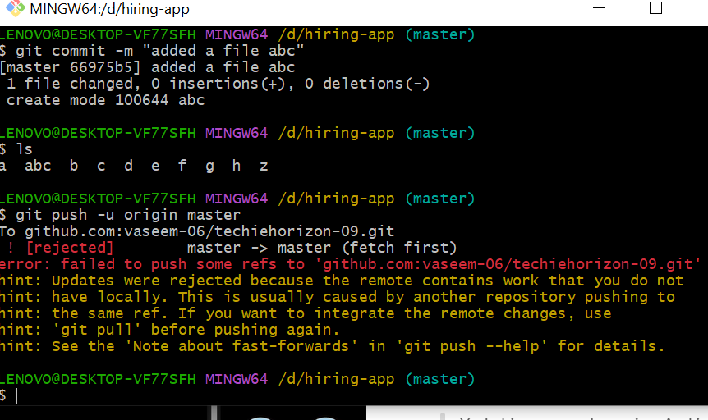

1. Here shows file name shoebpathan added in local machine and we have done that using git pull command

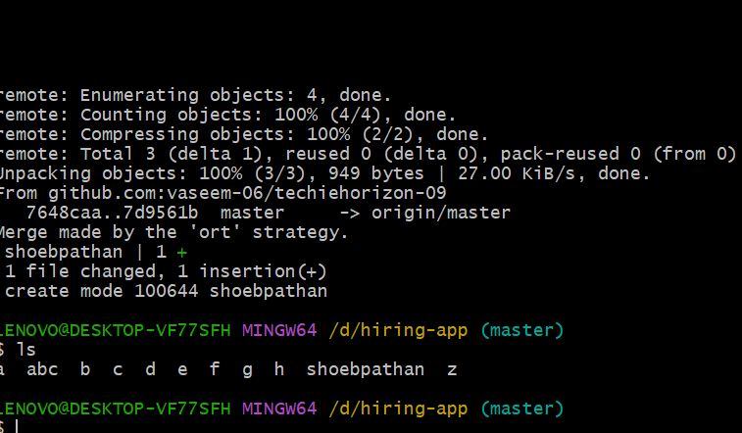

1. In this using the git clone it is created one directory similar to user name and if we go in this directory our files are there and git clone is use to download the complete repository

